ANNEXES Mangroves for the Future

Guidelines for Grant Facilities

[version 2014 12 15]

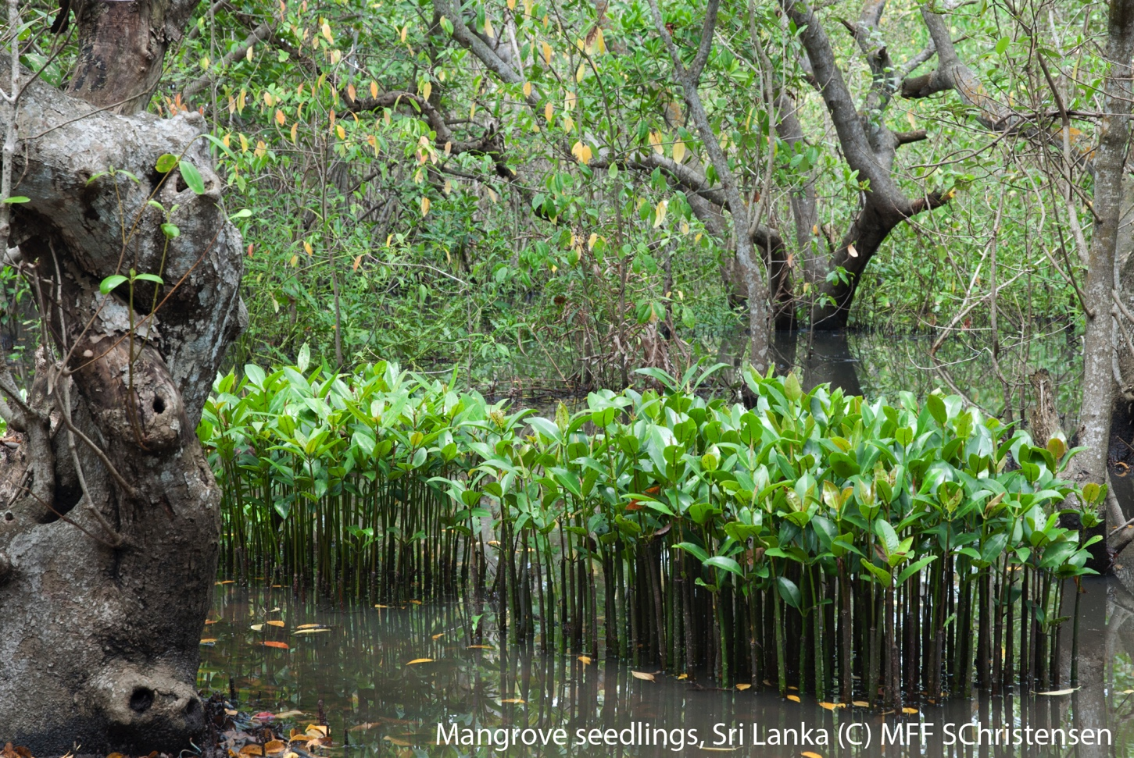

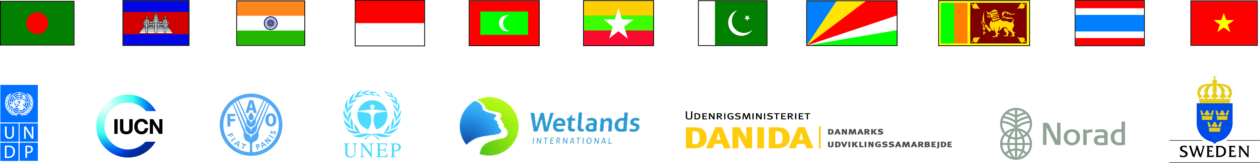

Annexes to Guidelines

Annex 1. MFF Objectives and Strategic Focus Areas

Annex 2. Template for Concept Note for Small Grant Facility

Annex 3. Template for Full Proposals for Small Grant Facility

Annex 4. Template for Concept Note for Small Grant Facility for Private Sector engagement

Annex 5. Template for Full Proposals for Small Grant Facility for Private Sector engagement

Annex 6. Template for Concept Note for Medium Grant Facility

Annex 7. Template for Full Proposals for Medium Grant Facility

Annex 8. Template for Concept Note for Regional Grant Facility

Annex 9. Template for Full Proposals for Regional Grant Facility

Annex 10. Information on the Proponent Organization

Annex 11. Principles of Logframe Thinking, Linking Objectives to Activities, and Results-based Budgeting

Annex 1: MFF Objectives and Strategic Focus Areas

Outcome Objective: Resilience of ecosystem-dependent coastal communities strengthened

Output Objective 1: Knowledge generated, disseminated and applied for sustainable management of coastal ecosystems
  - Strengthening information base
  - Enhancing access to and sharing of knowledge at national and regional levels
  - Promoting effective use of knowledge including best practices

Output Objective 2: Key stakeholders empowered to engage in decision-making in support of sustainable management of coastal ecosystems

  - Building awareness and capacity of civil society and private sector
  - Supporting multi-stakeholder fora
  - Promoting sustainable livelihoods

Output Objective 3: Coastal governance enhanced to promote integrated and inclusive management

  - Strengthening capacity of national and regional governance institutions for integrated coastal management
  - Engaging with key business sectors to promote sustainable business practices
  - Promoting co-management and similar participatory natural resource management mechanisms

Gender equality and climate change were introduced as cross cutting issues in Phase 2 and property rights and land tenure and have been added together with conflict sensitivity in Phase 3.

Annex 2: Template for Concept Note Small Grant Facility

[May be prepared either in English or in a local language]

The Concept Note should be maximum two (2) pages (excluding the “Information on the Proponent Organization”) (Annex 10).

- Project title Should reflect the work of the project.

- Name of the Organisation

- Project idea (please provide short statements on the following questions)

  - What is the current situation, and the problem(s) to be addressed?

  - What are the main causes for this problem? Which of these causes does the project address and what is the rationale behind this choice?

  - Where did the idea for the project originate from?

  - Are there other organisations working on the same problem in the project area?

  - What would be the project’s Objective, Results (=Outputs) and deliverables

  - Who will benefit from the project?

  - What are the main changes expected by implementing the project which will benefit the status of the ecosystems and/or people dependent on the ecosystems?

- Where will the project be implemented?

- Relevance to the MFF criteria and the priorities indicated in the Call for Application

  - How would the project relate to the MFF Programmes of Work?

  - How does the project address priority issues identified in the Call for Application (please refer to the Call for Application made by the national MFF Secretariat)?

  - How would the project address the cross-cutting themes [climate change, gender, conflict sensitivity, and property rights and land tenure]? [see Section 1 of the Guidelines]

- Project duration (months)

- Project Management

  - Provide a brief statement on how the project will be managed.

  - List the partners involved in project implementation and their roles and responsibilities.

Partner | Roles and Responsibilities

- Budget (local currency):

Total Budget | Financing Plan
Total Budget | Request from MFF | Grantee Contribution | Other Contributions

Annex 3: Template for Full Proposals Small Grant Facility

[May be prepared either in English or in a local language]

- Proposal Summary Sheet [1 page] (Should be attached with each proposal)

- Date of Proposal Submission

- Project Title:

- Project Site: Exact location (village, province etc), District/State, Country

- Project Scale : National/ regional

- Implementation agency (Name and Address):

- Implementing Partners, if any:

- Authorized representatives from Implementing Agency: Name and designation of a key person from the proponent

- Project Objective:

- Project start date: DD/MM/YY

- Project duration: In months, not exceeding 18 months

- Brief Project description (with Deliverables):

- Total Project Cost (in local currency) and Financing Plan:

Total Budget | Financing Plan
Total Budget | Request from MFF | Grantee Contribution | Other Contributions
100% | XX% | YY% | ZZ%

- Full Proposal Template: The entire document should not exceed 15 pages.

- Project Summary: a brief statement of the problem, Objective(s), Results, main Activities and the ’change’ sought by the project

- Introduction

  - Rationale of the project: Situation Analysis, Main problem(s) to be considered

  - Context: Geographical context; climate, altitude, main ecological and socio-economic characteristics; policy context: relationship to national policies; community context

  - Description of project area: Include map and coordinates of project areas

- Project Description

  - Project’s Logical Framework: Please provide a logical framework of the project (see Annex 11) which should reflect the following:

- Goal (long term vision) towards which the project will contribute;
- Objective(s) of the Project that will be achieved by the project;
- Results that will contribute to each Objective together with Indicators;
- Key activities that will help achieve the Results, including deliverables.

  - A narrative of the Key Activities: This section should provide the details of how activities will be carried out, and should include the methodologies. This description should follow the following format:

Key Activity | Description on how it will be done, with whom etc.

Result # 1:

Activity 1.1

Activity 1.2

Result # 2

Activity 2.1

Activity 2.1

  - Benefits and Beneficiaries: What are the expected benefits of the project, and who are the beneficiaries, and how many are they? (specify numbers); highlight any livelihood linkages, if any.

  - Participation of local people and communities: Participation of local stakeholders including women and specific disadvantaged group, if any, in the project planning and implementation.

  - Cross-cutting themes: Describe how would the project address the cross-cutting themes [see Section 1 of the Guidelines].

  - Project’s risks, if any, and mitigation plans: Describe briefly the project’s risks and how these are to be managed.

  - Work-plan: Please provide a time frame in a Gantt chart as below, for each activity; the project should start immediately after the contract is signed. If there is special seasonal requirement (for example monsoon) it should be clearly expressed here.

Activities | Month
Activities | 1 | 2 | 3 | 4 | 5 | 6 | 7 | 8 | 9 | 10 | 11 | 12 | 13 | 14 | 15 | 16 | 17 | 18

Activity 1.1

Activity 1.2

etc.

- Project Management:

  - Management: How will the project be managed (institutional structure, other organizations involved)? If other organizations are involved, describe the responsibility of each partner and how they will work together to achieve the project objectives.

  - Monitoring, Learning and Evaluation: How and when will the internal monitoring and evaluation take place? What is the process for capturing the lessons from the project? What is the situation about the baseline of the Indicators? If the baseline is not available, what is proposed to generate the baseline?

- Continuation of project activities: Exit strategy/ Phase-out mechanism and how project results will continue to be sustained after the funding ends.

- Budget: Create a detailed Results/Activities-based budget based on the logframe (See Annex 6); this budget should also include co-financing, both cash and in-kind. The budget should contain all direct costs relating to activities; the management component should not exceed10% of the total budget.

- Proponent Description: In addition to the information provided in Annex 5, please provide the following information:

  - Organisational background: [Up to 150 words]

  - Capacity of the proponent to undertake this work – indicate briefly the roles and responsibilities of proponent’s staff members, their qualifications and experiences for the tasks to be performed.

  - Prior experience in the related projects: Describe, in 100-150 words for each project, up to a maximum of three projects that have been completed most recently, the Outcomes/Impacts of the projects completed.

Annex 4: Template for Concept Note for Small Grant Facility for Private Sector engagement

[Must be prepared in English]

The Concept Note should be maximum two (2) pages (excluding the “Information on the Proponent Organization”) (Annex 10).

- Project title Should reflect the work of the project.

- Name of the Organisation

- Name of the co-funding private sector:

- Project idea (please provide short statements on the following questions)

  - What is the current situation, and the problem(s) to be addressed?

  - What are the main causes for this problem? Which of these causes does the project address and what is the rationale behind this choice?

  - Where did the idea for the project originate from?

  - Are there other organisations working on the same problem in the project area?

  - What would be the project’s Objective, Results (=Outputs) and deliverables

  - Who will benefit from the project?

  - What are the main changes expected by implementing the project which will benefit the status of the ecosystems and/or people dependent on the ecosystems?

- Where will the project be implemented?

- Relevance to the MFF criteria and the priorities indicated in the Call for Application

  - How would the project relate to the MFF objectives and one or more of the nine focus areas defined in the MFF Phase 3 Project Document?

  - How does the project address priority issues identified in the Call for Application (please refer to the Call for Application made by the national MFF Secretariat)?

  - How would the project address the cross-cutting themes [climate change, gender equality Conflict Sensitivity, and Property Rights and Land Tenure]? [see Section A of the Guidelines]

- Project duration (months)

- Project Management

  - Provide a brief statement on how the project will be managed.

  - List the Partners involved in project implementation and their roles and responsibilities.

Partner | Roles and Responsibilities

- Budget (local currency):

Total Budget | Financing Plan
Total Budget | Request from MFF | Co-funding from private company | Contribution from grantee | Other Contributions

Annex 5: Template for Full Proposals for Small Grant Facility for Private Sector engagement

- Proposal Summary Sheet [1 page] (Should be attached with each proposal)

- Date of Proposal Submission

- Project Title:

- Project Site: Exact location (village, province etc), District/State, Country

- Project Scale: National/ regional

- Implementation agency (Name and Address):

- Co-funding private sector:

- Implementing Partners, if any:

- Authorized representatives from Implementing Agency: Name and designation of a key person from the proponent

- Project Objective:

- Project start date: DD/MM/YY

- Project duration: In months, not exceeding 18 months

- Brief Project description (with Deliverables):

- Total Project Cost (in local currency) and Financing Plan:

Total Budget | Financing Plan
Total Budget | Request from MFF | Co-funding from private company | Contribution from grantee | Other Contributions

- Full Proposal Template: The entire document should not exceed 15 pages.

- Project Summary: a brief statement of the problem, Objective(s), Results, main Activities and the ’change’ sought by the project

- Introduction

  - Rationale of the project: Situation Analysis, Main problem(s) to be considered

  - Context: Geographical context; climate, altitude, main ecological and socio-economic characteristics; policy context: relationship to national policies; community context

  - Description of project area: Include map and coordinates of project areas

- Project Description

  - Project’s Logical Framework: Please provide a logical framework of the project (see Annex 6) which should reflect the following:

- Goal (long term vision) towards which the project will contribute;
- Objective(s) of the Project that will be achieved by the project;
- Results that will contribute to each Objective together with Indicators;
- Key activities that will help achieve the Results, including deliverables.

  - A narrative of the Key Activities: This section should provide the details of how activities will be carried out, and should include the methodologies. This description should follow the following format:

Key Activity | Description on how it will be done, with whom etc.

Result # 1:

Activity 1.1

Activity 1.2

Result # 2

Activity 2.1

Activity 2.1

  - Benefits and Beneficiaries: What are the expected benefits of the project, and who are the beneficiaries, and how many are they? (specify numbers); highlight any livelihood linkages, if any.

  - Participation of local people and communities: Participation of local stakeholders including women and specific disadvantaged group, if any, in the project planning and implementation.

  - Cross-cutting themes: Describe how would the project address the cross-cutting themes [see Section 1 of the Guidelines].

  - Project’s risks, if any, and mitigation plans: Describe briefly the project’s risks and how these are to be managed.

  - Work-plan: Please provide a time frame in a Gantt chart as below, for each activity; the project should start immediately after the contract is signed. If there is special seasonal requirement (for example monsoon) it should be clearly expressed here.

Activities | Month
Activities | 1 | 2 | 3 | 4 | 5 | 6 | 7 | 8 | 9 | 10 | 11 | 12 | 13 | 14 | 15 | 16 | 17 | 18

Activity 1.1

Activity 1.2

etc.

- Project Management:

  - Management: How will the project be managed (institutional structure, other organizations involved)? If other organizations are involved, describe the responsibility of each partner and how they will work together to achieve the project objectives.

  - Monitoring, Learning and Evaluation: How and when will the internal monitoring and evaluation take place? What is the process for capturing the lessons from the project? What is the situation about the baseline of the Indicators? If the baseline is not available, what is proposed to generate the baseline?

- Continuation of project activities: Exit strategy/ Phase-out mechanism and how project results will continue to be sustained after the funding ends.

- Budget: Create a detailed Results/Activities-based budget based on the logframe (See Annex 11); this budget should also include co-financing, both cash and in-kind. The budget should contain all direct costs relating to activities; the management component should not exceed10% of the total budget.

- Proponent Description: In addition to the information provided in Annex 10, please provide the following information:

- Organisational background: [Up to 150 words]

- Capacity of the proponent to undertake this work – indicate briefly the roles and responsibilities of proponent’s staff members, their qualifications and experiences for the tasks to be performed.

- Prior experience in the related projects: Describe, in 100-150 words for each project, up to a maximum of three projects that have been completed most recently, the Outcomes/Impacts of the projects completed.

Annex 6: Template for Concept Note - Medium Grant Facility

[Should be prepared in English]

The Concept Note should be a maximum of six (6) pages (excluding the “Information on the Proponent Organization”) (Annex 10).

- Date of Proposal Submission

- Project Title: Should reflect the work of the project.

- Project Site: As specific as possible, attach a general map, as applicable.

- Project Scale : National/ regional

- Implementation agency: Name and Address of the Organization

- Implementing partners : with a brief description of their roles and responsibilities

- Authorized representatives from Implementing Agency: Name and designation of a key person from the Organization.

- Project start date: DD/MM/YY

- Project duration: In months, not exceeding 24 months

- Brief Project description (as elaborated below):

  - Rationale of the project: A detailed Situation Analysis, problem identification, justification of why the project is necessary and interventions to be considered to address the problem(s).

  - Context of the project: brief description of ecology, community, policies and climate change concerns, if any. How is the project related to MFF Programmes of Work and MFF Country priorities?

  - Project description: Please provide the project’s logical framework (see Annex 11) which should reflect the following:
- Goal (long term vision) towards which the project will contribute;
- Objective(s) of the Project that will be achieved by the project;
- Results that will contribute to each Objective together with Indicators;
- Key activities that will help achieve the Results, including deliverables.

Please provide a brief narrative on how the activities will be implemented. Does the project build on a previous project? If so describe the Outcomes of the previous project and justify the need for the proposed project and how it will strengthen the situation.

  - Project Beneficiaries, Outcomes and Impacts: Who are the beneficiaries (identify who and specify numbers) or what are the improvements to the ecosystem? What are the ‘changes’ sought out by the Project? Briefly outline the Outcomes (benefits to the stakeholders/participants) and Impacts (when the benefits to the stakeholders/participants are achieved, what changes in organizations, communities or coastal ecosystems might be expected to occur).

  - Cross-cutting themes: Describe how would the project address the [see Section 1 of the Guidelines]

  - Project sustainability: The exit strategy - how will the project’s Outcomes be sustained after this funding ceases?

  - Project Risks and Assumptions: Describe potential barriers to the implementation of projects and how they will be overcome.

- Project Budget: Please provide a framework budget (in local currency) and financing plan in the following format:

Item | Amount
- Activities
- Personnel
- Travel

TOTAL

Financing Plan:

Total Budget | Financing Plan
Total Budget | Request from MFF | Grantee Contribution | Other Contributions
100% | XX% | YY% | ZZ%

Annex 7: Template for Full Proposals Medium Grant Facility

[Should be prepared in English]

- Proposal summary sheet [1 page] (Should be attached with each proposal)

- Date of Proposal Submission

- Project Title:

- Project Site: Exact location (village, province etc), District/State, Country

- Project Scale : National/ regional

- Implementation agency (Name and Address)

- Implementing Partners

- Authorized representatives from Implementing Agency: Name and designation of a key person from proponent

- Project Objective:

- Project start date: DD/MM/YY

- Project duration: In months, not exceeding 24 months

- Brief Project description (with Results and Deliverables):

- Total Project Cost (in local currency) and Financing Plan:

Total Budget | Financing Plan
Total Budget | Request from MFF | Grantee Contribution | Other Contributions
100% | XX% | YY% | ZZ%

- Full proposal template

- INTRODUCTION

      - Background

      - Project context; detailed Situation Analysis, Problem Identification and Justification for the Project

      - Related projects/other relevant activities

      - Preparatory activities already undertaken to identify the project

      - The Project’s relevance to MFF and national MFF priorities
- PROJECT DESCRIPTION

- Statement on the Goal, Project Objective(s) and Results, and describe how the Results contribute to MFF Programmes of Work and other MFF national priorities; the logframe should be furnished as an Annex to the proposal.

- Project Beneficiaries: Who are the beneficiaries (identify who and specify numbers) or what are the improvements to the ecosystem?

- A narrative on activities to support the Results, Outcomes and Impacts: What are the ‘changes’ sought out by the Project? Briefly outline the Outcomes (benefits to the stakeholders/participants) and Impacts (when the benefits to the stakeholders/ participants are achieved, what changes in organizations, communities or coastal ecosystems might be expected to occur).

- Strategies to address cross-cutting themes

- Inputs required (physical resources, manpower, financial summary)

- ASSUMPTIONS and RISKS

  - Commitment of Stakeholders

  - Institutional support

  - Accountability

  - Sustainability and Replicability: What is the exit strategy - how will the project’s Outcomes be sustained after this funding ceases?

- PROJECT MANAGEMENT and ORGANISATION

  - National Level

  - Local level(s)

  - Procedures for Implementation: In addition to the description of procedures, please also include a narrative on the following:

    - Implementing partners, including the lead implementing agency; the roles and responsibilities of Partners. The working and communication arrangements between the partners should also be explained clearly.

    - The proposal should clearly indicate the involvement and roles and responsibilities, if any, of the key stakeholders (including the Government if relevant).

  - Financial Management and Procurement

- MONITORING, LEARNING & EVALUATION

  - Internal Monitoring and Evaluation System and frequency of monitoring;

  - A description of the baseline information available, as basis for monitoring

  - Capturing learning and dissemination of project’s results and outcomes

- ANNEXES (as appropriate)

- Logical Framework

- Site description (with maps, photos where relevant)

- Detailed Budget and disbursement plan

- Project organization chart

- TOR/Job Descriptions for project implementing personnel

Annex 8: Template for Concept Note - Regional Grant Facility

[Should be prepared in English]

The Concept Note should be a maximum of six (6) pages (excluding the “Information on the Proponent Organization”) (Annex 10).

- Date of Proposal Submission

- Project Title: Should reflect the work of the project.

- Project Site: As specific as possible, attach a general map, as applicable.

- Project Scale : National/ regional

- Implementation agency: Name and Address of the Organization

- Implementing partners : with a brief description of their roles and responsibilities

- Authorized representatives from Implementing Agency: Name and designation of a key person from the Organization.

- Project start date: DD/MM/YY

- Project duration: In months, not exceeding 24 months

- Brief Project description(as elaborated below):

  - Rationale of the project: A detailed Situation Analysis, problem identification, justification of why the project is necessary and interventions to be considered to address the problem(s).

  - Context of the project: brief description of ecology, community, policies and climate change concerns, if any. How is the project related to MFF Programmes of Work and MFF Country priorities?

  - Project description: Please provide the project’s logical framework (see Annex 6) which should reflect the following:
- Goal (long term vision) towards which the project will contribute;
- Objective(s) of the Project that will be achieved by the project;
- Results that will contribute to each Objective together with Indicators;
- Key activities that will help achieve the Results, including deliverables.

Please provide a brief narrative on how the activities will be implemented. Does the project build on a previous project? If so describe the Outcomes of the previous project and justify the need for the proposed project and how it will strengthen the situation.

  - Project Beneficiaries, Outcomes and Impacts: Who are the beneficiaries (identify who and specify numbers) or what are the improvements to the ecosystem? What are the ‘changes’ sought out by the Project? Briefly outline the Outcomes (benefits to the stakeholders/participants) and Impacts (when the benefits to the stakeholders/participants are achieved, what changes in organizations, communities or coastal ecosystems might be expected to occur).

  - Cross-cutting themes: Describe how would the project address the [see Section A of the Guidelines]

  - Project sustainability: The exit strategy - how will the project’s Outcomes be sustained after this funding ceases?

  - Project Risks and Assumptions: Describe potential barriers to the implementation of projects and how they will be overcome.

- Project Budget: Please provide a framework budget (in local currency) and financing plan in the following format:

Item | Amount
- Activities
- Personnel
- Travel

TOTAL

Financing Plan:

Total Budget | Financing Plan
Total Budget | Request from MFF | Grantee Contribution | Other Contributions
100% | XX% | YY% | ZZ%

Annex 9: Template for Full Proposals Regional Grant Facility

[Should be prepared in English]

- Proposal summary sheet [1 page] (Should be attached with each proposal)

- Date of Proposal Submission

- Project Title:

- Project Site: Exact location (village, province etc), District/State, Country

- Project Scale : National/ regional

- Implementation agency (Name and Address)

- Implementing Partners

- Authorized representatives from Implementing Agency: Name and designation of a key person from proponent

- Project Objective:

- Project start date: DD/MM/YY

- Project duration: In months, not exceeding 24 months

- Brief Project description (with Results and Deliverables):

- Total Project Cost (in local currency) and Financing Plan:

Total Budget | Financing Plan
Total Budget | Request from MFF | Grantee Contribution | Other Contributions
100% | XX% | YY% | ZZ%

- Full proposal template

- INTRODUCTION

      - Background

      - Project context; detailed Situation Analysis, Problem Identification and Justification for the Project

      - Related projects/other relevant activities

      - Preparatory activities already undertaken to identify the project

      - The Project’s relevance to MFF and national MFF priorities
- PROJECT DESCRIPTION

- Statement on the Goal, Project Objective(s) and Results, and describe how the Results contribute to MFF Programmes of Work and other MFF national priorities; the logframe should be furnished as an Annex to the proposal.

- Project Beneficiaries: Who are the beneficiaries (identify who and specify numbers) or what are the improvements to the ecosystem?

- A narrative on activities to support the Results, Outcomes and Impacts: What are the ‘changes’ sought out by the Project? Briefly outline the Outcomes (benefits to the stakeholders/participants) and Impacts (when the benefits to the stakeholders/ participants are achieved, what changes in organizations, communities or coastal ecosystems might be expected to occur).

- Strategies to address cross-cutting themes

- Inputs required (physical resources, manpower, financial summary)

- ASSUMPTIONS and RISKS

  - Commitment of Stakeholders

  - Institutional support

  - Accountability

  - Sustainability and Replicability: What is the exit strategy - how will the project’s Outcomes be sustained after this funding ceases?

- PROJECT MANAGEMENT and ORGANISATION

  - National Level

  - Local level(s)

  - Procedures for Implementation: In addition to the description of procedures, please also include a narrative on the following:

    - Implementing partners, including the lead implementing agency; the roles and responsibilities of Partners. The working and communication arrangements between the partners should also be explained clearly.

    - The proposal should clearly indicate the involvement and roles and responsibilities, if any, of the key stakeholders (including the Government if relevant).

  - Financial Management and Procurement

- MONITORING, LEARNING & EVALUATION

  - Internal Monitoring and Evaluation System and frequency of monitoring;

  - A description of the baseline information available, as basis for monitoring

  - Capturing learning and dissemination of project’s results and outcomes

- ANNEXES (as appropriate)

- Logical Framework

- Site description (with maps, photos where relevant)

- Detailed Budget and disbursement plan

- Project organization chart

- TOR/Job Descriptions for project implementing personnel

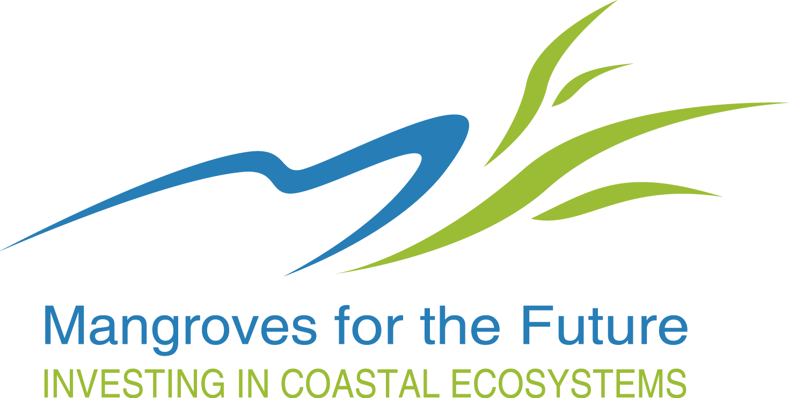

Annex 10: Information on the Proponent Organization

NOTE: Please fill in this form and send it with the Concept Note

Project Title

Name of the Organization

Mailing Address

Visiting Address (if different from above)
Telephone |  |  |  | Fax
Email |  |  |  | Website

Mission and Goal of the Organization
About the Organization | Registration date
About the Organization | Category
About the Organization | Contact person
About the Organization | Number of staff
Bank Account details | Account name
Bank Account details | Bank name
Bank Account details | Bank address
Bank Account details | Account No.:
Bank Account details | SWIFT or other routing code
Bank Account details | Signatories names
References | Name, address and Tel no. (Referee 1)
References | Name, address and Tel no. (Referee 2)

Projects implemented during the last 5 years relevant to the theme of the current proposal
Title of the Project |  | Donor/Amount |  |  | Reference (Name/tel/email)

Annex 11: Principles of Logframe Thinking, Linking Objectives to Activities, and Results-based Budgeting

Logical framework, or logframe, thinking starts out with a simple but extremely important principle: first, one decides where to go (the objective) and, secondly, how one will get there (the activity). Objectives are formulated which can be achieved by performing a set of activities. , But because activities are at a much lower level than Objectives, each activity normally contributes to a Result; one or more Results are needed to enable the Objective to be achieved.

Logframe thinking requires clear (or at least plausible) specifications of the intended effects of planned Results. Thus, the "hierarchy of objectives" is linked by a set of hypotheses indicating the intended impact, i.e., the utilization of Results and, ultimately, the accruing benefits. The linkages have to be "tight", i.e., chances to reach higher level objectives must be good. Realism and consistency refer to scientifically sound hypotheses and to available resources. By linking resources, r, and long-term effect (=impact) in a realistic and consistent manner, logframes create a high degree of transparency and thus they provide a sound basis for efficient management, meaningful evaluation, and enhanced credibility.

The logframe process also includes a reflection on important external factors which are crucial for the success of a given project. "Assumptions" are hypotheses about factors which are outside the managerial control of a project, centre, or the system as a whole.

The "logframe matrix" which summarizes all important planning decisions, assumptions, and resource allocations is a frame which has to be specified for operational purposes. It has, therefore, to be supplemented by detailed (operational) plans specifying activities, milestones, responsibilities, time schedules, resources, etc.

The terminology used world-wide in logframes is chaotic. It is therefore necessary to understand the hierarchy, rather than being confused with different terms used by different agencies. In this we use the term GOAL to denote long term achievements which are not expected out of this project, but it will contribute towards it. Goal is followed by OBJECTIVES which should be achieved by the Project. A set of RESULTS enable one to achieve the Objectives, while each Result is achieved through a set of ACTIVITIES.

A sample logframe of a hypothetical project is provided below together with a budget linking Results/ Activities to expenditure, for guidance.

SAMPLE LOGICAL FRAMEWORK MATRIX

Restoration of coastal mangroves in Abeecee Village, Beedee Province, [country]

Intervention Logic | Objectively Verifiable Indicators (OVIs) | Source of Verification (SoV) | Assumptions

Goal

Peoples’ lives and property are protected from storms and flooding | - Deaths and economic losses from storm surges | - Village administration reports | - Mangroves are effective against storms and waves

Objectives

- A coastal protection zone of mangroves in Abeecee Village in Beedee Province is created | - Extent of new mangrove planting (3 km) | - Village reports | - Village coastline is suitable for mangrove planting
 | - Trained guards undertake village protection | - Village reports | - Guards are willing
 | - Village Disaster Risk Reduction Plan contains Mangrove protection guidelines | - Village DRR plans | - Authorities willing to include mangrove protection in DRR
- Project Management functioning well. | - Establishment of a project team with the requisite competencies for work described earlier.  - Establishment of a system for regular consultation with the stakeholders;  - Day-to-day management of the Project, including reporting | - Project Team;  - Stakeholder consultation reports  - Project Office reports

Results/Key activities per Objectives

Results |  | Key Activities |  |  |  |  | Deliverables/Responsibility

Objective 1 - A coastal protection zone of mangroves in Abeecee Village in Beedee Province is created

- A 3-km mangrove plantation along the coastline of the village |  | - Establishment of a mangrove nursery; |  |  |  |  | - Proper Mangrove nursery
 |  | - Collection of planting materials to raise 60,000 seedlings |  |  |  |  | - 60,000 seedlings
 |  | - Planting mangroves |  |  |  |  | - 3 km length planted
 |  | - Quarterly monitoring of planting (2 years) |  |  |  |  | - Seven (7) monitoring reports
 |  | - Gap filling |  |  |  |  | - No. of plants used in gap filling
- Trained village guard team in mangrove protection |  | - Construction of two guard posts to accommodate mangrove guards and procurement of basic equipment |  |  |  |  | - Two Guard posts  - Basic equipment (torches, tools, water-proof clothing)
 |  | - Developing a training module for guards |  |  |  |  | - Training module
 |  | - Conducting two training course for guards (10 per team) |  |  |  |  | - Two training events
- Mangrove protection regulations integrated into the village Disaster Risk Reduction Plan |  | - Workshop to develop mangrove protection regulations |  |  |  |  | - Mangrove protection regulations
 |  | - Consultative meeting with relevant agencies to incorporate mangrove protection regulations in village Disaster Risk Reduction Plans |  |  |  |  | - Incorporating mangrove protection regulations into DRR
 |  | - Radio broadcasts to inform people about the importance of protecting mangroves and penalties for not following regulations |  |  |  |  | - Content of awareness broadcasts;  - Ten (10) broadcasts over a period of three months

Objective 2 - Project Management functioning well.

- Project Team |  | - Appointment of a project team with the requisite competencies. |  |  |  |  | - Project cell
 |  | - Establishment of a system for regular consultation with the stakeholders; |  |  |  |  | - Meeting reports
- Project Management |  | - Day-to-day management of the Project, including reporting |  |  |  |  | - Reports

Restoration of coastal mangroves in Abeecee Village, Beedee Province, [country]

No. | Category & Item of Expenditure |  | Unit | Unit Price (USD) | Quantity | Cost |  |  | Sub Total | Remarks

Objective 1 - A coastal protection zone of mangroves in Abeecee Village in Beedee Province is created

Result 1: A 3-km mangrove plantation along the coastline of the village
Activity 1.1: Establishment of a mangrove nursery |  |  |  |  |  |  |  |  | 1,250
 | Land preparation & maintenance |  | day | 5 | 100 | 500
 | Fencing |  | lump |  |  | 250
 | Construction of room |  | lump |  |  | 500
Activity 1.2; Raising seedlings |  |  |  |  |  |  |  |  | 2,300
 | Planting materials |  | Unit | 0.03 | 60000 | 1,800
 | Other materials |  | lump |  |  | 250
 | Miscellaneous costs |  | lump |  |  | 250
Activity 1.3: Planting mangroves |  |  |  |  |  |  |  |  | 2,500
 | Payment for planting |  | person day | 5 | 500 | 2,500
Activity 1.4: Quarterly monitoring of planting (2 years) & Gap Filling |  |  |  |  |  |  |  |  | 786
 | Planting materials |  | Unit | 0.03 | 1200 | 36
 | Monitoring by community |  | day | 5 | 100 | 500 |  |  |  | In kind from community
 | Payment for planting |  | day | 5 | 50 | 250

Result 2: Trained village guard team in mangrove protection
Activity 2.1: Construction of guard posts and providing basic equipment |  |  |  |  |  |  |  |  | 1,050
 | Construction costs |  | Lump |  |  | 750 |  |  |  | In kind from Partner
 | Basic equipment |  | Lump |  |  | 300
Activity 2.2: Developing a training module for guards |  |  |  |  |  |  |  |  | 1,250
 | Technical advice |  | day | 50 | 25 | 1,250 |  |  |  | In kind from Partner
Activity 2.3:Training of Guards |  |  |  |  |  |  |  |  | 550
 | Venue |  | day | 25 | 2 | 50
 | Training materials |  | Lump |  |  | 100
 | Refreshments |  | pax | 5 | 20 | 100
 | Technical support |  | day | 50 | 6 | 300 |  |  |  | In kind from Partner

Result # 3: Mangrove protection regulations integrated into the village Disaster Risk Reduction Plan
Activity 3.1: Workshop to develop mangrove protection regulations |  |  |  |  |  |  |  |  | 400
 | Venue |  | day | 25 | 1 | 25
 | Refreshments |  | pax | 5 | 25 | 125
 | Technical support |  | day | 50 | 5 | 250 |  |  |  | In kind from Partner
Activity 3.2: Consultative meeting with agencies |  |  |  |  |  |  |  |  | 200
 | Meeting costs |  | Lump |  |  | 100
 | Technical support |  | day | 50 | 2 | 100 |  |  |  | In kind from Partner
Activity 3.3: Radio broadcasts |  |  |  |  |  |  |  |  | 750
 | Development of content |  | day | 50 | 5 | 250
 | Broadcast costs |  | Unit | 50 | 10 | 500

Objective # 2 - Project Management functioning well.
 | Project Management |  |  |  |  |  |  |  | 5,350
 | Reporting |  | Year | 250 | 2 | 500
 | Other costs |  | Year | 250 | 2 | 500
 | Project Manager |  | Month | 100 | 24 | 2,400 |  |  |  | In kind from Grantee
 | Mangrove Guard |  | Month | 50 | 24 | 1,200
 | Miscellaneous labour |  | day | 5 | 150 | 750
 | TOTAL |  |  |  |  |  |  |  | 16,386
 | FINANCING PLAN (USD)
 | In kind from Partner |  |  |  |  |  |  | 2,650
 | In kind from Community |  |  |  |  |  |  | 500
 | In kind from Grantee |  |  |  |  |  |  | 2,400
 | Mangroves for the Future Grant |  |  |  |  |  |  | 10,836
 | TOTAL |  |  |  |  |  |  | 16,386

-end-

Other terms used for Goal are: Long Term Objective; Overall Objective; Strategic Objective; Development Objective
Other terms used for Objectives are: Immediate Objective; Project Purpose; Medium Term Result; Intermediate Result
Other terms used for Results are: Outputs; short term Result

