
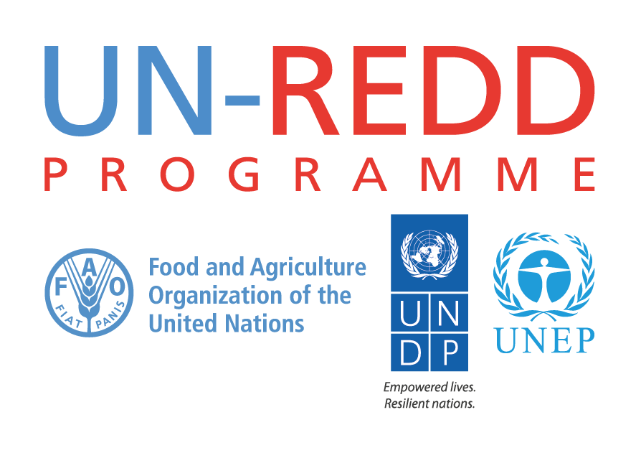
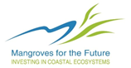

REDD+ Academy for MFF IUCN Staff in Asia Regional

Norad/ Nicfi REDD+ and Mangroves Project Inception Phase

In Partnership with the UN-REDD Programme

Date: 22-26 January 2018
Venue: Compass SkyView Hotel, Sukhumvit 24,
Bangkok

Introduction:
Mangroves for the Future (MFF) is a partner-led initiative to promote investment in coastal ecosystem conservation for sustainable development. Co-chaired by IUCN and UNDP, MFF provides a platform for collaboration among the many different agencies, sectors and countries which are addressing challenges to coastal ecosystem and livelihood issues. The goal is to promote an integrated ocean-wide approach to coastal management and to building the resilience of ecosystem-dependent coastal communities. MFF builds on a history of coastal management interventions before and after the 2004 Indian Ocean tsunami. It initially focused on the countries that were worst affected by the tsunami - India, Indonesia, Maldives, Seychelles, Sri Lanka and Thailand. More recently it has expanded to include Bangladesh, Cambodia, Myanmar, Pakistan and Viet Nam.
Mangroves are the flagship of the initiative, but MFF is inclusive of all types of coastal ecosystem, such as coral reefs, estuaries, lagoons, sandy beaches, seagrasses and wetlands.
The MFF grants facility offers small, medium and large grants to support initiatives that provide practical, hands-on demonstrations of effective coastal management in action. Each country manages its own MFF programme through a National Coordinating Body which includes representation from government, NGOs and the private sector. MFF addresses priorities for long-term sustainable coastal ecosystem management which include, among others: climate change adaptation and mitigation, disaster risk reduction, promotion of ecosystem health, development of sustainable livelihoods, and active engagement of the private sector in developing sustainable business practices.

The emphasis of MFF is on generating knowledge, empowering local communities and advocating for policy solutions that will support best practice in integrated coastal management.

As part of the inception phase for the new component of the Mangroves for the Future (MFF) Programme to include mangroves and associated coastal ecosystems in the REDD+ agenda in the Asia region, MFF is organizing a 5-day training course in partnership with the UN-REDD Programme which associated with the three UN agencies including UNDP. UNEP, and FAO as capacity development initiative.

Overall Objective of the REDD+ Academy Training Event:
The main purpose of the training is to build a knowledge base for REDD+ readiness and implementation on the ground, with a specific focus on developing capacity to integrate mangrove/coastal forest ecosystems in the REDD+ process. Training participants are made up of MFF national/regional staff engaged in coordinating and supporting the work of MFF programme and other IUCN staff members from the Asia region. A group of between 20 and 25 people is expected to take part in the training.

The overall expectation is to build capacity and knowledge of MFF secretariat and other IUCN staff from the region in general and to provide the strategic guidance and direction for the project inception and implementation phase of the Norad project under MFF.

Design Process:
The REDD+ Academy will adopt a classic training approach. The training will provide the main structure and content for the 5-day training to be delivered by Regional Technical Advisors (RTAs) from across the three partner UN agencies (UN-REDD). MFF is aware that there is a need to tailor some of the content, references and case studies to be discussed within the 12 modules in order to address the uniqueness of mangrove forest conservation and management as compared to that of terrestrial forest ecosystems. In this respect MFF is interested to explore how and where the content of some of the modules/ topics might be adapted to include more of a focus on mangrove forest ecosystems where relevant and to provide resources for external experts if necessary to work with the UN-REDD RTAs to achieve this.

Participants:
Around 20-25 participants including nine MFF National Coordinators from; Bangladesh, Cambodia, India, Indonesia, Myanmar, Pakistan, Sri Lanka, Thailand and Viet Nam; 5-6 BKK-based MFF staff; plus, additional staff from the IUCN regional office and country offices; Bangladesh, Vietnam, Cambodia, Sri Lanka.

Training Modules:
In total, there are 12 modules developed for REDD+ Academy Training. An outline of the modules is provided in Annex 1. The detail training modules or learning journals can be accessed at: click here.

Training Expert/Facilitator:
- Bruno Hugel, Global Technical Advisor – National REDD+ Strategies, UNDP/UN-REDD
- Celina Yong, Regional Stakeholder Engagement Specialist, UNDP/UN-REDD
- Charlotte Hicks, Programme Officer, Climate Change and Biodiversity, UNEP-WCMC
- Emelyne Cheney, Regional Advisor – Forest and Climate Change, UNEP/UN-REDD
- Joel Scriven, Regional Technical Advisor, UNDP/UN-REDD
- Khin Hnin Myint, National Programme Manager, UN-REDD Myanmar
- Mahmood Abu, Forest Officer, FAO/UN-REDD
- Steven Swan, REDD+ Safeguards Coordinator, UNEP/UN-REDD
- Timothy Boyle, Regional Technical Advisor, UNDP/UN-REDD
- Heang Thy, REDD+ Training Coordinator

Tentative Agenda:
The five-day training event will be take place from 22-26 January 2018. The agenda and breakdown of the five-day training event is provided below.

Time | Topic Time | Topic | Presenter/Facilitator
Day 1, Morning: Forest and Climate Change, and REDD+ and UNFCCC, and Drivers
08:00 – 09:00 | 20 mins | Opening remarks | Aban Marker Kabraji  Timothy Boyle
08:00 – 09:00 | 20 mins | Introductions and | Heang Thy
08:00 – 09:00 | 15 mins | Sharing experiences from other NICFI/Norad REDD+ projects | Sofi Obrestad Halling
09:00 – 10:00 | 60 mins | Topic 1: Forest, Carbon Sequestration and Climate Change | Ben Vickers
10:00 – 10:30 | Coffee Break
10:30 – 12:00 | 90 mins | Topic 2: Understanding REDD+ and the UNFCCC | Khin Hnin Myint
12:00 – 13:30 | Lunch
Day 1, Afternoon: Drivers of Deforestation and Forest Degradation
13:30 – 14:00 | 30 mins | Energiser/Afternoon review | Participant/Heang Thy
14:00 – 16:00 | 120 mins | Topic 3: Drivers of Deforestation and Forest Degradation | Khin Hnin Myint
16:00 – 16:30 | Coffee Break
16:30 – 17:00 | 30 mins | Daily Review | Participant/Heang Thy
17:00 – 17:30 | 30 mins | Internal review | IUCN/UN-REDD/Heang
18:00 | Welcoming dinner |  | All
Day 2: Morning: REDD+ National Strategies or Action Plans
08:00 – 08:15 | 15 mins | Morning review | Participant/Heang Thy
08:15 – 09:45 | 90 mins | Topic 4: REDD+ National Strategies or Action Plans (NS/AP) | Bruno Hugel
09:45 – 10:15 | Coffee Break
10:15 – 12:00 | 105 mins | Topic 4: REDD+ NS/AP (contd) | Bruno Hugel
12:00 – 13:30 | Lunch
Day 2: Afternoon: National Forest Monitoring Systems
13:30 – 13:45 | 15 mins | Energiser/Afternoon review | Participant/Heang Thy
13:45 – 15:00 | 75 mins | Topic 5: National Forest Monitoring Systems for REDD+ (NFMS) | Mahmood Abu (Jamil)
15:00 – 15:30 | Coffee break
15:30 – 16:45 | 75 mins | Topic 5: NFMS (contd.) | Jamil
16:45 – 17:00 | 15 mins | Daily Review | Participant/Heang Thy
17:00 – 17:30 | 30 mins | Internal Review | IUCN/UN-REDD/Heang Thy
Day 3 Morning: Forest Reference Emission Levels/Forest Reference Levels
08:00 – 08:15 | 15 mins | Morning review | Participant/Heang Thy
08:15 – 09:45 | 90 mins | Topic 6: Forest Reference [Emission] Levels (FREL) | Jamil
09:45 – 10:15 | Coffee break
10:15 – 12:00 | 105 mins | Topic 6: FREL (contd.) | Jamil
12:00 – 13:30 | Lunch
Day 3 Afternoon: Polices and Measures
13:30 – 13:45 | 15 mins | Energiser/Afternoon review | Participant/Heang Thy
13:45 – 15:00 | 75 mins | Topic 7: Policies and Measures (PAMs) for REDD+ Implementation | Bruno Hugel
15:00 – 15:30 | Coffee break
15:30 – 16:45 | 75 mins | Topic 7: PAMs (contd.) | Bruno Hugel
16:45 – 17:00 | 15 mins | Daily review | Participant/Heang Thy
17:00 – 17:30 | 60 mins | Internal Review | IUCN/UN-REDD/Heang Thy
Day 4 Morning: Safeguards and SIS
08:00 – 08:15 | 15 mins | Morning review | Participant/Heang Thy
08:15 – 09:45 | 90 mins | Topic 8: REDD+ Safeguards under the UNFCCC | Steven Swan
09:45 – 10:15 | Coffee break
10:15 – 12:00 | 105 mins | Topic 8: REDD+ Safeguards (contd.) | Steven Swan
12:00 – 13:30 | Lunch
Day 4 Afternoon: REDD+ Finance
13:30 – 13:45 | 15 mins | Energiser/Afternoon review | Participant/Heang Thy
13:45 – 15:00 | 74 mins | Topic 9: REDD+ Finance | Timothy Boyle
15:00 – 15:30 | Coffee break
15:30 – 16:45 | 75 mins | Topic 9: REDD+ Finance (contd.) | Timothy Boyle
16:45 – 17:00 | 15 mins | Daily Review | Participant/Heang Thy
17:00 – 17:30 | 30 mins | Internal Review | IUCN/UN-REDD/Heang Thy
Day 5 Morning: Incentive Allocation and Stakeholder Engagement
08:00 – 08:15 | 15 mins | Morning review | Participant/Heang Thy
08:15 – 09:45 | 90 mins | Topic 10: Approaches for Allocation of Incentives | Charlotte Hicks
09:45 – 10:00 | Coffee Break
10:00 – 12:00 | 120 mins | Topic 11: Introduction to Stakeholder Engagement in REDD+ | Celina Yong
12:00 – 13:30 | Lunch
Day 5 Afternoon: Good Governance and Wrap-up
01:30 – 13:45 | 15 mins | Afternoon review | Heang Thy
13:45 – 15:30 | 105 mins | Topic 12: Good Governance | Emelyne Cheney
15:30 – 16:00 | Coffee Break
16:00 – 17:30 | 90 mins | - Training Review and wrap-up  - Way forwards | Celina Yong  IUCN/Nightingale Maeve

Outline of REDD+ Academy Modules:
Note that the structure and content of REDD+ Academy modules continues to be refined.
Modules | Description
- Forest, Carbon Sequestration and Climate Change | The role that forest ecosystems play in the global carbon cycle; the multiple functions and benefits of forests; and different methods for quantifying and valuing the multiple benefits of forests.  There is increasing evidence from around the world that the Earth’s climate is changing and human activity is the most likely cause. The carbon cycle means that vegetation (including forests), soils, oceans and the atmosphere are connected, and it is important to consider the role vegetation and changes in vegetation cover play in controlling overall greenhouse gas emissions and hence climate change. As forests contain substantial stores of carbon, their degradation and or conversion to other land cover causes the release of some of the carbon stored within them, conversely their restoration can act as a sink for atmospheric carbon. The UNFCC developed REDD+, reducing emissions from deforestation and forest degradation plus the conservation of forest carbon stocks, sustainable management of forests and enhancement of forest carbon stocks, recognizing the potential role of forests in contributing to climate change mitigation.  Introduction to Coastal Habitats and Climate Change will be also included in this module presentation.
- Understanding REDD+ and the UNFCCC | Scientific evidence on climate change (IPCC); Review of the fundamentals of REDD+; the UNFCC process and the phases of REDD+; international commitments and programmes for REDD+. Mangrove options in NDCs will be integrated in the presentation.
- Drivers of Deforestation and Degradation (DFDD) | In the context of REDD+, ‘drivers’ are actions and processes that result in deforestation and forest degradation. Understanding the key DFDD is important for several reasons and particularly critical for the development of national REDD+ strategies and/or action plans and the formulation of policies and measures. Some specific challenges in drivers of degradation in mangroves and regulatory issues and land tenure will be also highlighted.
- REDD+ National Strategies and Action Plans (NS/AP | UNFCC provisions on REDD+ National Strategies and Action Plans (NS/AP); analysing and addressing the drivers of deforestation and forest degradation; the purpose and content of, and process of designing a NS/AP; the institutional framework and national capacities that need to be in place for REDD+ readiness and implementation processes to unfold in effective and equitable manner.
- National Forest Monitoring Systems (NFMS) | Basic requirements for countries under the UNFCCC: The development and implementation of national forest monitoring systems in order to deliver national MRV (Measuring, Reporting, and Verification) and monitoring capacity for REDD+ and other international processes; most recent IPCC guidance and guidelines; different components of comprehensive and modern MRV systems; community and participatory monitoring of forests; and the role of technology, including remote sensing techniques, for efficient MRV systems and the establishment of a national reference scenario for REDD+; tools and methodologies to measure carbon stocks and flows in different forest systems.
- Forest Reference Emission Levels (FREL) | The development of national Reference Emission Levels, including how to establish and communicate the reference emission levels and/or forest reference levels under the UNFCCC.
- Policies and Measures (PAMs) | PAMs can be understood as actions taken and/or mandated by government. In the context of climate change, PAMs can guide actions to mitigate climate change by reducing the concentration of greenhouse gases (GHG) in the atmosphere and enhancing removals of atmospheric carbon. In the context of REDD+, PAMs aim to guide the implementation of REDD+ activities (emissions reductions and/or removals), as decided by a country, potentially in combination with other objectives (such as integrated rural development and sectoral transformation).
- Safeguards | The Cancun safeguards and SIS requirements; proposed country approaches to the Cancun safeguards; the opportunities for “win-win” situations as well as compromises or trade-offs that can exist between maximising carbon sequestration and other benefits, such as biodiversity and food security; the different risks associated with reforms and investments in the forest and related sectors, in particular for vulnerable people and the environment; and the way information is provided to the UNFCCC on addressing and respecting safeguards.
- REDD+ Finance | However, in order to get receive results-based payments/finance, a country need to tackle the direct and underlying drivers of deforestation and identify what are the best incentive structures and response measures to achieve that at national (or sub-national) level. So the broader perspective of REDD+ finance also includes understanding and addressing the economic and financial drivers that currently contribute to deforestation, as well as assessing the effect of (changing) deforestation rates on gross domestic product. Climate finance and blue investments will be also incorporated and presented.
10. Approaches for Allocation of Incentives | The pros and cons of different approaches regarding benefits sharing of carbon revenues; the positive development outcomes triggered by performance-base management in the forest and related sectors; the role of national incentive frameworks to address drivers of detestation (including taxation, subsidies and trade); the role of forest-related reforms and investments to shape a more sustainable and equitable development pathway; the use of prospective models, to support policy decisions towards the green economy; the potential of generating green jobs through forest-related interventions; and the types of forest/land related investments that can trigger positive spill-over effects on the economy and help reduce inequalities.
11. Stakeholder Engagement in REDD+ | The importance of stakeholder engagement in all stages of REDD+; key elements of good communication and public awareness; the importance of gender considerations in REDD+; methods and tools to strengthen the full and effective participation of stakeholders; transparency and accountability mechanisms (including free, prior and informed consent, forest law enforcement and governance); key aspects of private sector engagement in REDD+, including public-private partnerships. Strategies for engagement – within and outside the Paris Agreement will also be presented.
12. Good Governance | Principles of credible and inclusive national governance for REDD+ implementation; the legal and policy provisions that need to be in place for REDD+ results-base actions; the role of anti-corruption, rule of law, transparency and accountability and other good governance measures in the success of reforms and investments in forest-related sectors; the importance of and differences between ownership of land (tenure) and access and usage rights to forests and forest goods and services; the main elements of land tenure and the importance of secure land tenure in the context of REDD+.

