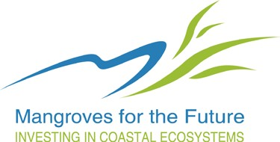

Mangroves for the Future
Template: Concept Note and Full Proposals

Regional Grant Facility
(Annexes to MFF Guidelines to Grant Facilities)

Effective date: 01 July 2013

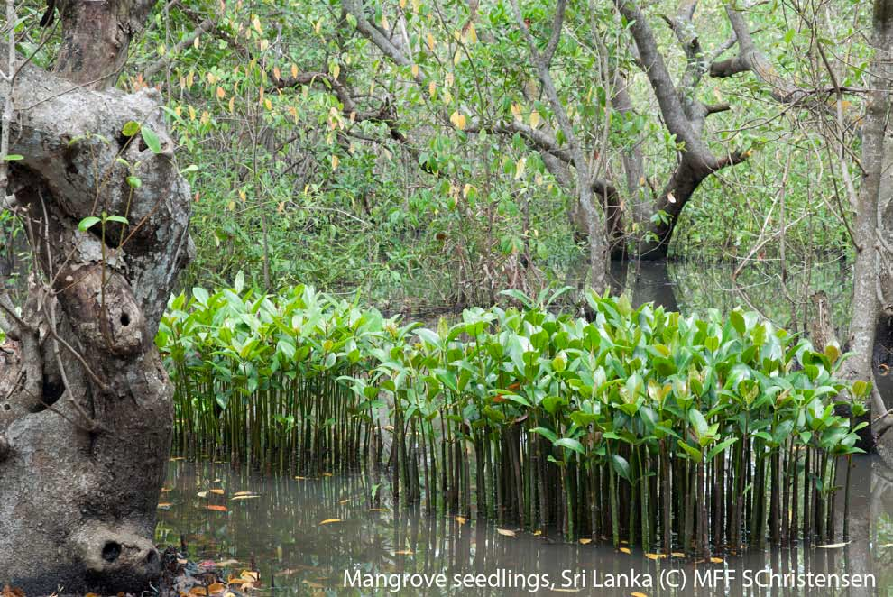

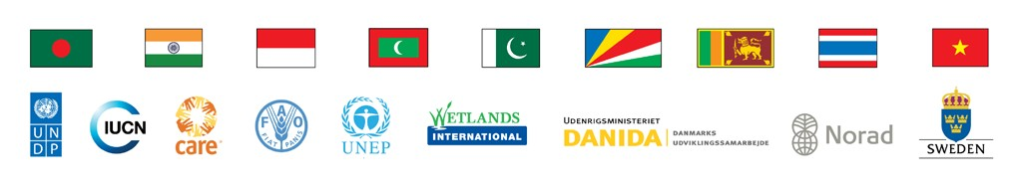

Templates for Regional Grant Facility
(Annexes to MFF Guidelines to Grant Facilities)

Annex 3. Template for Concept Note for Regional Grant Facility
Annex 4. Template for Full Proposals for Regional Grant Facility
Annex 5. Information on the Proponent Organization
Annex 6. Principles of Logframe Thinking, Linking Objectives to Activities, and Results-based Budgeting

Annex 3:
Template for Concept Note: Regional Grant Facility

[Should be prepared in English]

The Concept Note should be a maximum of six (6) pages (excluding the “Information on the
Proponent Organization”)( Annex 5).

1. Date of Proposal Submission

2. Project Title: Should reflect the work of the project.

3. Project Site: As specific as possible, attach a general map, as applicable.

4. Project Scale: National/ regional

5. Implementation agency: Name and Address of the Organization

6. Implementing partners: with a brief description of their roles and responsibilities

7. Authorized representatives from Implementing Agency: Name and designation of a key person from the Organization.

8. Project start date: DD/MM/YY

9. Project duration: In months, not exceeding 24 months

10. Brief Project description (as elaborated below):

(a) Rationale of the project: A detailed Situation Analysis, problem identification, justification of why the project is necessary and interventions to be considered to address the problem(s).

(b) Context of the project: brief description of ecology, community, policies and climate change concerns, if any. How is the project related to MFF Programmes of Work and MFF Country priorities?

(c) Project description: Please provide the project’s logical framework (see Annex 6) which should reflect the following:

▪ Goal (long term vision) towards which the project will contribute;
▪ Objective(s) of the Project that will be achieved by the project;
▪ Results that will contribute to each Objective together with Indicators;
▪ Key activities that will help achieve the Results, including deliverables.

Please provide a brief narrative on how the activities will be implemented.

Does the project build on a previous project? If so describe the Outcomes of the previous project and justify the need for the proposed project and how it will strengthen the situation.

(d) Project Beneficiaries, Outcomes and Impacts: Who are the beneficiaries (identify who and specify numbers) or what are the improvements to the ecosystem? What are the
‘changes’ sought out by the Project? Briefly outline the Outcomes (benefits to the
stakeholders/participants) and Impacts (when the benefits to the stakeholders/participants are achieved, what changes in organizations, communities or coastal ecosystems might be expected to occur).

(e) Cross-cutting themes: Describe how would the project address the cross-cutting themes
[climate change, gender equality & communications]? [see Section A of the MFF Guidelines to Grant Facilities]

(f) Project sustainability: The exit strategy - how will the project’s Outcomes be sustained after this funding ceases?

(g) Project Risks and Assumptions: Describe potential barriers to the implementation of projects and how they will be overcome.

14. Project Budget: Please provide a framework budget (in local currency) and financing plan in the following format:

Item | Amount
(a) Activities
(b) Personnel
(c) Travel
TOTAL

Financing Plan:

Total Budget | Financing Plan
Total Budget | Request from MFF | Grantee  Contribution | Other Contributions
100% | XX% | YY% | ZZ%

Annex 4:
Template for Full Proposal Regional Grant Facility

[Should be prepared in English]

A. Proposal summary sheet [1 page] (Should be attached with each proposal)

1. Date of Proposal Submission

2. Project Title:

3. Project Site: Exact location (village, province etc), District/State, Country

4. Project Scale: National/ regional

5. Implementation agency (Name and Address)

6. Implementing Partners

7. Authorized representatives from Implementing Agency: Name and designation of a key person from proponent

8. Project Objective:

9. Project start date: DD/MM/YY

10. Project duration: In months, not exceeding 24 months

11. Brief Project description (with Results and Deliverables):

12. Total Project Cost (in local currency) and Financing Plan:

Total Budget | Financing Plan
Total Budget | Request from MFF | Grantee  Contribution | Other Contributions
100% | XX% | YY% | ZZ%

B. Full proposal template

1. INTRODUCTION

1.1 Background

1.2 Project context; detailed Situation Analysis, Problem Identification and Justification for the Project

1.3 Related projects/other relevant activities

1.4 Preparatory activities already undertaken to identify the project

1.5 The Project’s relevance to MFF and national MFF priorities

2. PROJECT DESCRIPTION

2.1 Statement on the Goal, Project Objective(s) and Results, and describe how the Results contribute to MFF Programmes of Work and other MFF national priorities; the logframe should be furnished as an Annex to the proposal.

2.2 Project Beneficiaries: Who are the beneficiaries (identify who and specify numbers) or what are the improvements to the ecosystem?

2.3 A narrative on activities to support the Results, Outcomes and Impacts: What are the
‘changes’ sought out by the Project? Briefly outline the Outcomes (benefits to the stakeholders/participants) and Impacts (when the benefits to the stakeholders/ participants are achieved, what changes in organizations, communities or coastal ecosystems might be expected to occur).

2.4 Strategies to address cross-cutting themes (climate change, gender equality and communications)

2.5 Inputs required (physical resources, manpower, financial summary)

3. ASSUMPTIONS and RISKS

3.1 Commitment of Stakeholders

3.2 Institutional support

3.3 Accountability

3.4 Sustainability and Replicability: What is the exit strategy - how will the project’s
Outcomes be sustained after this funding ceases?

4. PROJECT MANAGEMENT and ORGANISATION

4.1 National Level

4.2 Local level(s)

4.3 Procedures for Implementation: In addition to the description of procedures, please also include a narrative on the following:

a. Implementing partners, including the lead implementing agency; the roles and responsibilities of Partners. The working and communication arrangements between the partners should also be explained clearly.

b. The proposal should clearly indicate the involvement and roles and responsibilities, if any, of the key stakeholders (including the Government if relevant).

4.4 Financial Management and Procurement

5. MONITORING, LEARNING & EVALUATION

5.1 Internal Monitoring and Evaluation System and frequency of monitoring;

5.2 A description of the baseline information available, as basis for monitoring

5.3 Capturing learning and dissemination of project’s results and outcomes

6. ANNEXES (as appropriate)

▪ Logical Framework

▪ Site description (with maps, photos where relevant)

▪ Detailed Budget and disbursement plan

▪ Project organization chart

▪ TOR/Job Descriptions for project implementing personnel

Annex 5:

Information on the Proponent Organization

NOTE: Please fill in this form and send it with the Concept Note

Project Title
Name of the Organization
Mailing Address

Visiting Address (if different from above)
Telephone |  |  |  |  | Fax
Email |  |  |  |  | Website
Mission and Goal of the Organization
About the Organization |  |  | Registration date
Category
Contact person
Number of staff
Bank Account details |  |  | Account name
Bank name
Bank address
Account No.:
SWIFT or other routing code
Signatories names
References |  | Name, address and Tel no. (Referee 1)
 |  | Name, address and Tel no. (Referee 2)
Projects implemented during the last 5 years relevant to the theme of the current proposal
Title of the Project |  |  |  | Donor/Amount |  |  | Reference (Name/tel/email)

Annex 6:
Principles of Logframe Thinking, Linking Objectives to Activities, and Results- based Budgeting

Logical framework, or logframe, thinking starts out with a simple but extremely important principle: first, one decides where to go (the objective) and, secondly, how one will get there (the activity). Objectives are formulated which can be achieved by performing a set of activities. , But because activities are at a much lower level than Objectives, each activity normally contributes to a Result; one or more Results are needed to enable the Objective to be achieved.

Logframe thinking requires clear (or at least plausible) specifications of the intended effects of planned Results. Thus, the "hierarchy of objectives" is linked by a set of hypotheses indicating the intended impact, i.e., the utilization of Results and, ultimately, the accruing benefits. The linkages have to be "tight", i.e., chances to reach higher level objectives must be good. Realism and consistency refer to scientifically sound hypotheses and to available resources. By linking resources, r, and long-term effect (=impact) in a realistic and consistent manner, logframes create a high degree of transparency and thus they provide a sound basis for efficient management, meaningful evaluation, and enhanced credibility.

The logframe process also includes a reflection on important external factors which are crucial for the success of a given project. "Assumptions" are hypotheses about factors which are outside the managerial control of a project, centre, or the system as a whole.

The "logframe matrix" which summarizes all important planning decisions, assumptions, and resource allocations is a frame which has to be specified for operational purposes. It has, therefore, to be supplemented by detailed (operational) plans specifying activities, milestones, responsibilities, time schedules, resources, etc.

The terminology used world-wide in logframes is chaotic. It is therefore necessary to understand the hierarchy, rather than being confused with different terms used by different agencies. In this we use the term GOAL3 to denote long term achievements which are not expected out of this project, but it will contribute towards it. Goal is followed by OBJECTIVES4 which should be achieved by the Project. A set of RESULTS5 enable one to achieve the Objectives, while each Result is achieved through a set of ACTIVITIES.

A sample logframe of a hypothetical project is provided below together with a budget linking
Results/ Activities to expenditure, for guidance.

3 Other terms used for Goal are: Long Term Objective; Overall Objective; Strategic Objective; Development
Objective
4 Other terms used for Objectives are: Immediate Objective; Project Purpose; Medium Term Result; Intermediate Result
5 Other terms used for Results are: Outputs; short term Result

SAMPLE LOGICAL FRAMEWORK MATRIX

Restoration of coastal mangroves in Abeecee Village, Beedee Province, [country]

Intervention Logic | Objectively Verifiable  Indicators (OVIs) | Source of  Verification (SoV) | Assumptions
Goal
Peoples’ lives and property are protected from storms and flooding | ▪ Deaths and economic losses from storm surges | ▪ Village administratio n reports | ▪ Mangroves are effective  against  storms and waves
Objectives
1. A coastal protection zone of mangroves in Abeecee Village in Beedee Province is created | ▪ Extent of new mangrove planting (3 km) | ▪ Village reports | ▪ Village  coastline is suitable for mangrove planting
 | ▪ Trained guards undertake village protection | ▪ Village reports | ▪ Guards are willing
 | ▪ Village Disaster Risk Reduction Plan contains Mangrove protection guidelines | ▪ Village DRR  plans | ▪ Authorities willing to include mangrove protection in DRR
2. Project Management functioning well. | ▪ Establishment of a project team with the requisite competencies for work described earlier.  ▪ Establishment of a system for regular consultation with the stakeholders;  ▪ Day-to-day management of the Project, including reporting | ▪ Project  Team;  ▪ Stakeholder consultation reports  ▪ Project Office reports

Results/Key activities per Objectives

Results | Key Activities | Deliverables/Responsibility
Objective 1 - A coastal protection zone of mangroves in Abeecee Village in Beedee Province is created
(a) A 3-km mangrove plantation along the coastline of the village | (i) Establishment of a mangrove nursery; | ➢ Proper Mangrove nursery
 | (ii) Collection of planting materials to raise 60,000 seedlings | ➢ 60,000 seedlings
 | (iii) Planting mangroves | ➢ 3 km length planted
 | (iv) Quarterly monitoring of planting  (2 years) | ➢ Seven (7) monitoring reports
 | (v) Gap filling | ➢ No. of plants used in gap filling
(b) Trained village guard team in mangrove protection | (i) Construction of two guard posts to accommodate mangrove guards and procurement of basic equipment | ➢ Two Guard posts  ➢ Basic equipment (torches, tools, water-proof clothing)
(b) Trained village guard team in mangrove protection | (ii) Developing a training module for  guards | ➢ Training module
(b) Trained village guard team in mangrove protection | (iii) Conducting two training course for guards (10 per team) | ➢ Two training events
(c) Mangrove protection regulations integrated into the village Disaster Risk Reduction Plan | (i) Workshop to develop mangrove protection regulations | ➢ Mangrove protection regulations
 | (ii) Consultative meeting with relevant agencies to incorporate  mangrove protection regulations in village Disaster Risk Reduction Plans | ➢ Incorporating mangrove protection regulations into DRR
 | (iii) Radio broadcasts to inform  people about the importance of protecting mangroves and penalties for not following regulations | ➢ Content of awareness broadcasts;  ➢ Ten (10) broadcasts over a period of three months
Objective 2 - Project Management functioning well.
(a) Project Team | (i) Appointment of a project team  with the requisite competencies. | ➢ Project cell
(a) Project Team | (ii) Establishment of a system for  regular consultation with the stakeholders; | ➢ Meeting reports
(b) Project Management | (i) Day-to-day management of the  Project, including reporting | ➢ Reports

Restoration of coastal mangroves in Abeecee Village, Beedee Province, [country]

No. | Category & Item of  Expenditure | Unit | Unit  Price  (USD) | Quantity | Cost | Sub  Total | Remarks  In kind from community  In kind from  Partner  In kind from  Partner  In kind from  Partner
Objective 1 - A coastal protection zone of mangroves in Abeecee Village in Beedee
Province is created
Result 1: A 3-km mangrove plantation along the coastline of the village
Activity 1.1: Establishment of a mangrove nursery |  |  |  |  |  | 1,250
 | Land preparation &  maintenance | day | 5 | 100 | 500
 | Fencing | lump |  |  | 250
 | Construction of room | lump |  |  | 500
Activity 1.2; Raising seedlings |  |  |  |  |  | 2,300
 | Planting materials | Unit | 0.03 | 60000 | 1,800
 | Other materials | lump |  |  | 250
 | Miscellaneous costs | lump |  |  | 250
Activity 1.3: Planting mangroves |  |  |  |  |  | 2,500
 | Payment for planting | person day | 5 | 500 | 2,500
Activity 1.4: Quarterly monitoring of planting (2 years) & Gap Filling |  |  |  |  |  | 786
 | Planting materials | Unit | 0.03 | 1200 | 36
 | Monitoring by community | day | 5 | 100 | 500
 | Payment for planting | day | 5 | 50 | 250
Result 2: Trained village guard team in mangrove protection
Activity 2.1: Construction of guard posts and providing basic equipment |  |  |  |  |  | 1,050
 | Construction costs | Lump |  |  | 750
 | Basic equipment | Lump |  |  | 300
Activity 2.2: Developing a training module for guards |  |  |  |  |  | 1,250
 | Technical advice | day | 50 | 25 | 1,250
Activity 2.3:Training of Guards |  |  |  |  |  | 550
 | Venue | day | 25 | 2 | 50
 | Training materials | Lump |  |  | 100
 | Refreshments | pax | 5 | 20 | 100
 | Technical support | day | 50 | 6 | 300

In kind from
Result # 3: Mangrove protection regulations integrated into the village Disaster
Risk Reduction Plan
Activity 3.1: Workshop to develop mangrove protection regulations |  |  |  |  |  |  | 400
 | Venue | day | 25 | 1 | 25
 | Refreshments | pax | 5 | 25 | 125
 | Technical support | day | 50 | 5 | 250
Activity 3.2: Consultative meeting with agencies |  |  |  |  |  |  | 200
 | Meeting costs | Lump |  |  | 100
 | Technical support | day | 50 | 2 | 100
Activity 3.3: Radio broadcasts |  |  |  |  |  |  | 750
 | Development of content | day | 50 | 5 | 250
 | Broadcast costs | Unit | 50 | 10 | 500
Objective # 2 - Project Management functioning well.
 | Project Management |  |  |  |  |  | 5,350
 | Reporting | Year | 250 | 2 | 500
 | Other costs | Year | 250 | 2 | 500
 | Project Manager | Month | 100 | 24 | 2,400
 | Mangrove Guard | Month | 50 | 24 | 1,200
 | Miscellaneous labour | day | 5 | 150 | 750
 | TOTAL |  |  |  |  |  | 16,386
 | FINANCING PLAN (USD)
 | In kind from Partner |  |  |  |  | 2,650
 | In kind from Community |  |  |  |  | 500
 | In kind from Grantee |  |  |  |  | 2,400
 | Mangroves for the Future Grant |  |  |  |  | 10,836
 | TOTAL |  |  |  |  | 16,386

Partner

In kind from
Partner

In kind from
Grantee

-end-

